Experiment #**3**

Function Generator

Kamyar Rahmani

810199422

Mohammad Mashreghi

810199492

Abstract**—In this document, we are going to design an Arbitrary function generator (AFG) with different waves, frequencies, and amplifier, and after that we are going to use Quartus and then use FPGA and uploaded it.**

Keywords**— Waveform Generator, Frequency, ROM, Selector, Amplitude Selector, PWM, DDS, Counter,**

**Function Generator, Arbitrary Function Generator**

1. Introduction

In this document, we are going to design an Arbitrary Generator that consists of a waveform generator, Amplitidude selector, DAC, and frequency selector.



Fig. 1 Block diagram of the Arbitrary Generator

1. waveform generator

In Waveform generator we designed 6 different weveforms and we use a ROM for showing another waveform that we’ve got before.

Fig. 2 Function selection

For generating Square, Triangle, and Reciprocal we use a 8-bit counter inside the wave generator

Fig. 3 wave of Square, Triangle and Reciprocal

And for the next three waves, at first we need to know how to create sin and after that we create full and half wave rectified.

For generating sin we use 2nd ODE formula and waveform clock as you can see:

$$\sin\left(n\right)= \sin\left(n-1\right)+ \frac{1}{64} \cos\left(n\right)$$

$$\cos{(n)}= \cos{(n-1)}+ \frac{1}{64}\sin\left(n\right)$$

$$Initial Value: \sin\left(0\right)=0 \& \cos{(0)}=3000$$

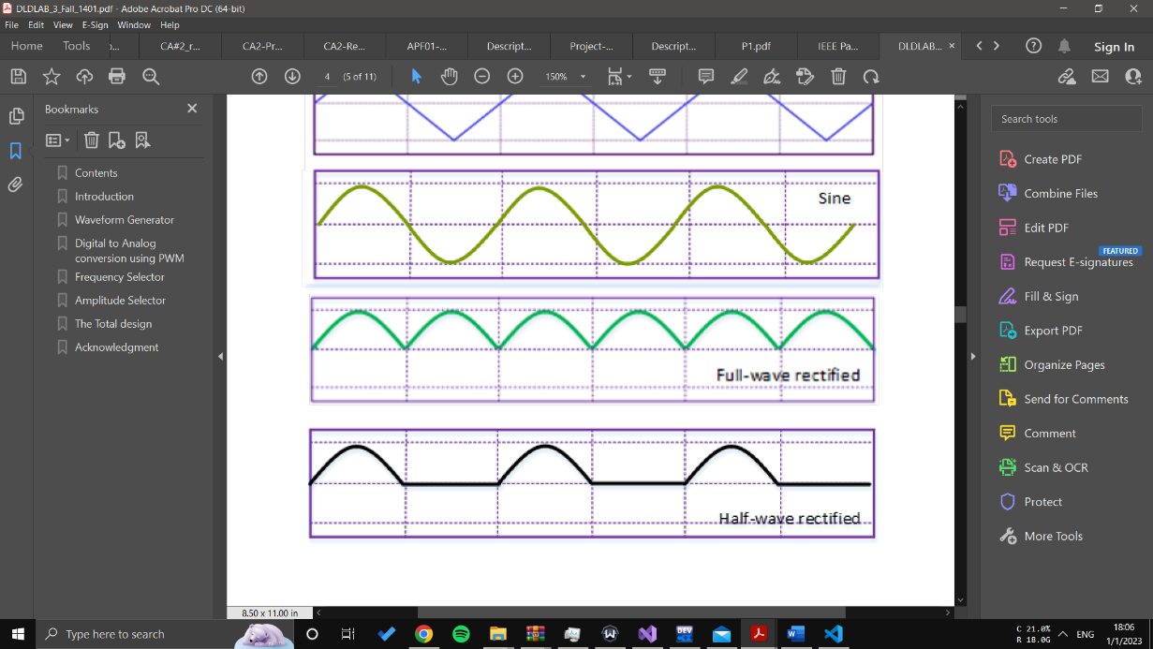

Fig. 3 wave of sin, half wave rectified and full wave rectified

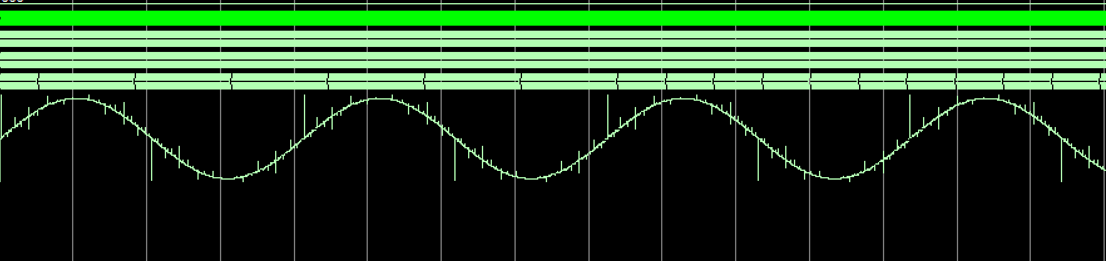Testbench result:

Fig. 4 wave of sin in testbench

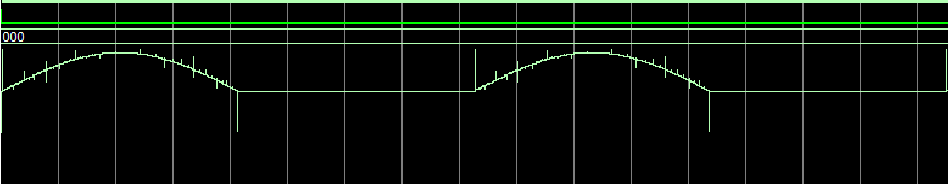

Fig. 5 wave of half wave rectified in testbench

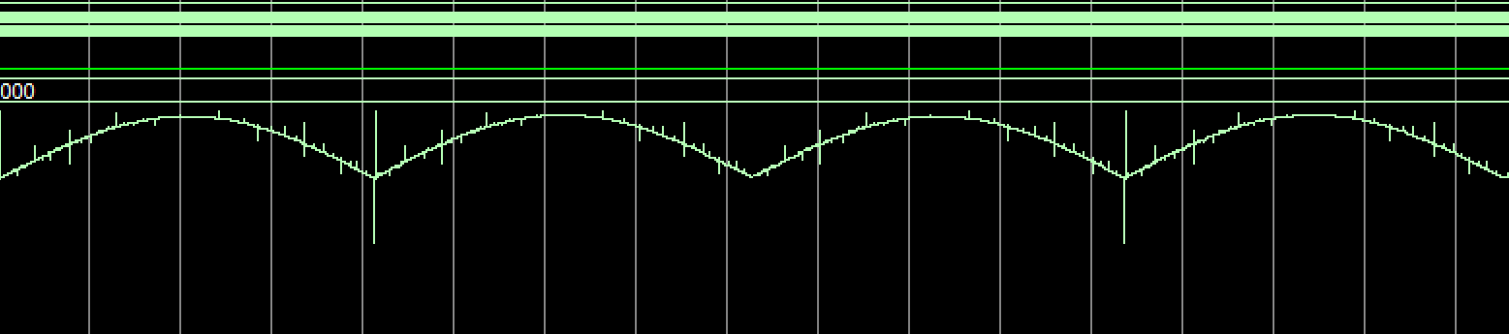

Fig. 6 wave of full wave rectified in testbench

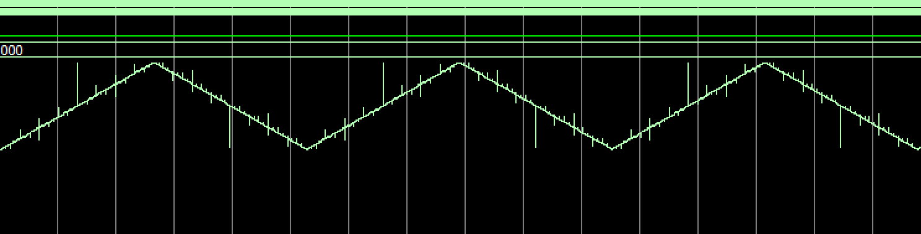

Fig. 7 wave of triangle in testbench

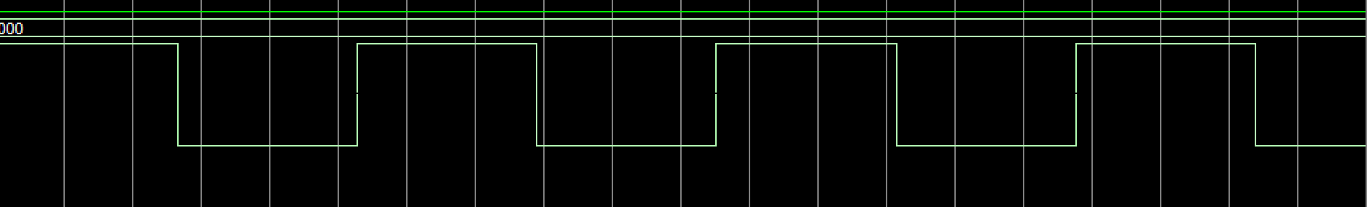

Fig. 8 wave of square in testbench



Fig. 9 Block diagram of waveform generator

Another way to generate wave is Direct Digital Synthesis (DDS) in this method we use adder , reg and ROM that used saved data and we can change its period with phase cntrl.

1. PWM

In this part we need a digital to analog conversion (DAC) and one of the cheapest methode is Pulse Width Modulation that we use and it use 8-bit counter inside it.

* When the input signal is larger than counter the output is **1.**
* When the input signal is less than counter the output is **0.**

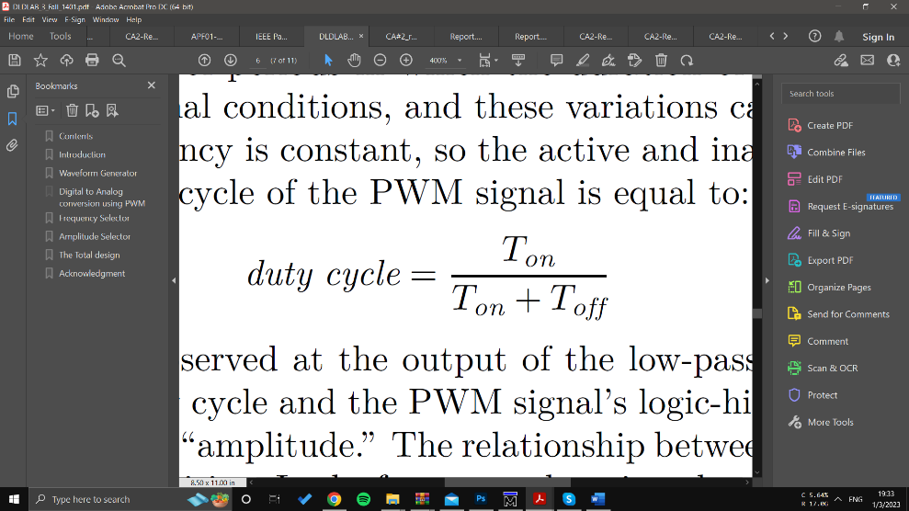



Fig. 10 Pulse Width Modulation (PWM)

1. **Frequency selector**

Arbitrary Generator usually have frequency selector to change its wave frequency according to the need of user.

In this part we use 9-bit counter and we set the first three bit for the change frequency and other bits our define before.



Fig. 11 Block diagram of frequency selector

1. **Amplitude selector**

Another option of Arbitrary Generator is a amplitude selector that scale down the amplitude of the waveforms.



Table 2: Amplitude selection

1. 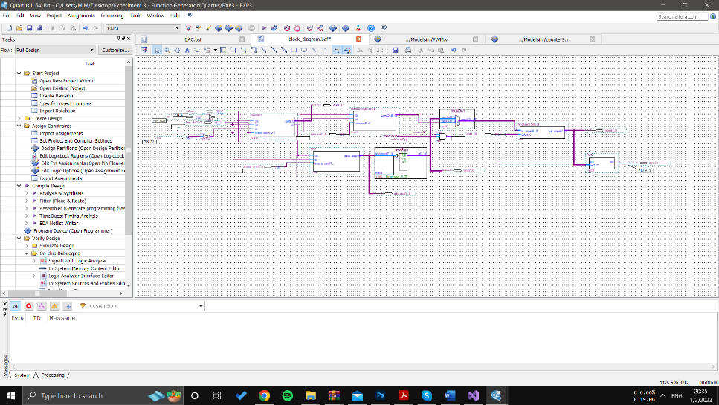**Actions**

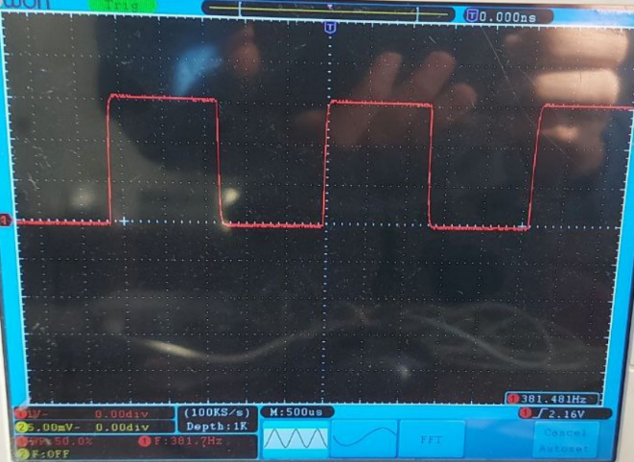

Fig. 16 Square

Fig. 12 Final block diagram of design

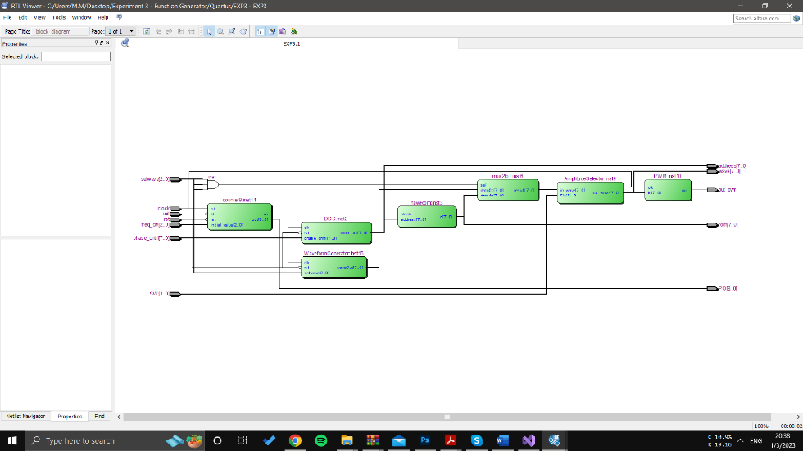

Fig. 13 RTL view

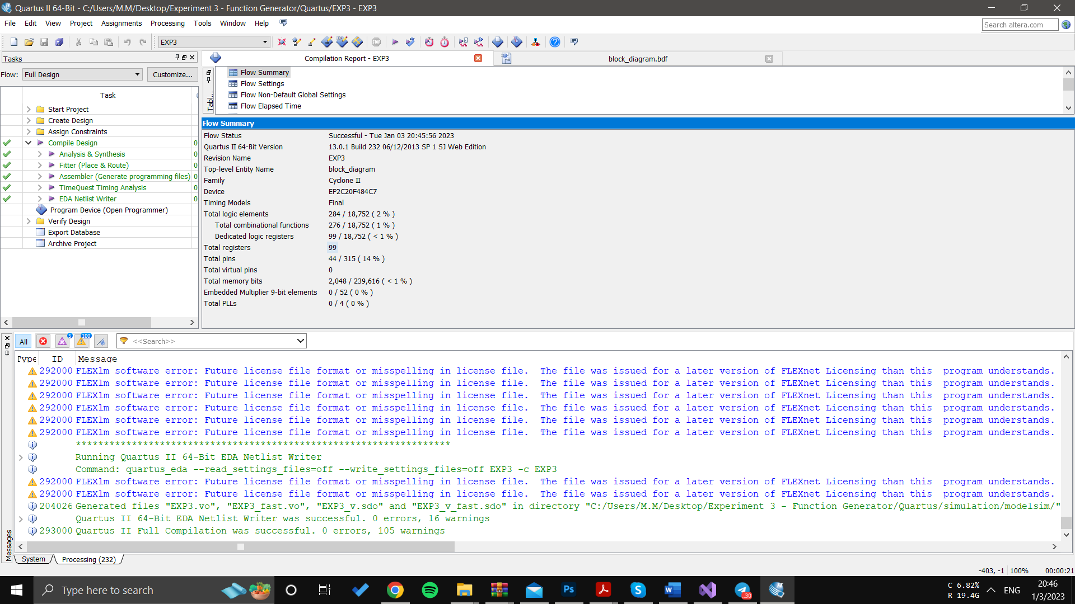

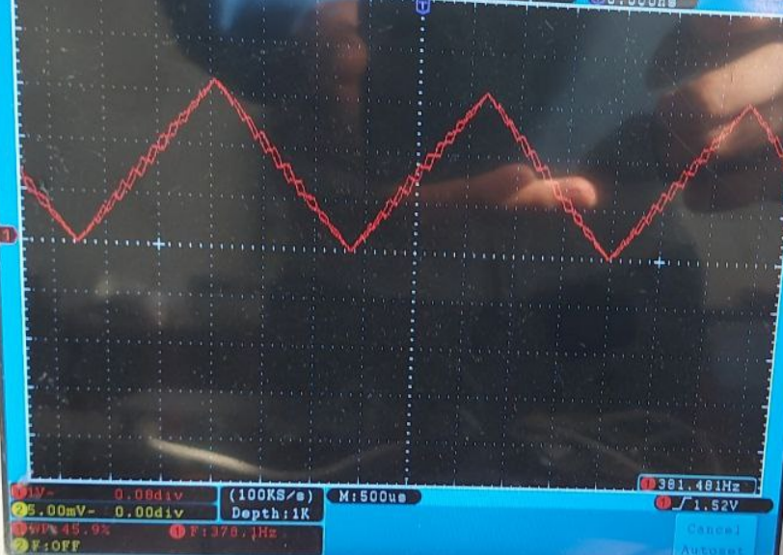

Fig. 14 Flow Summary

Fig. 17 Triangle

1. **Total Design**

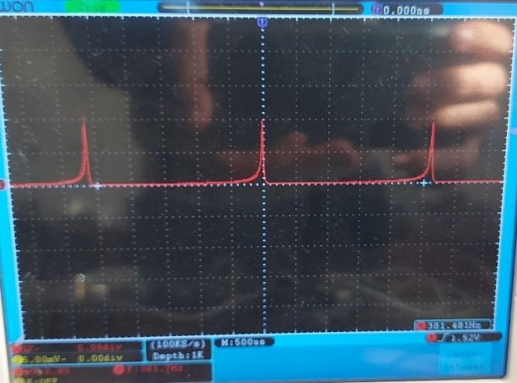

Fig. 15 Reciprocal

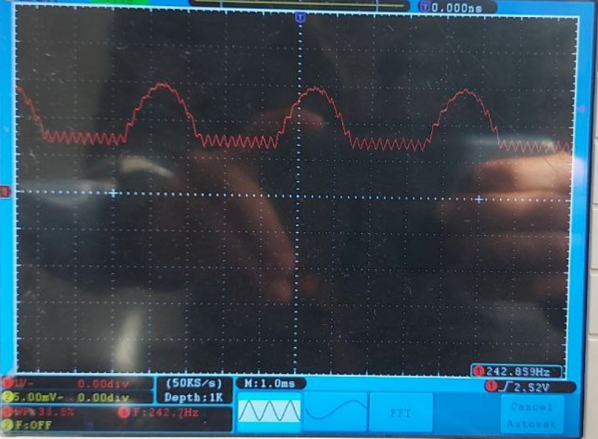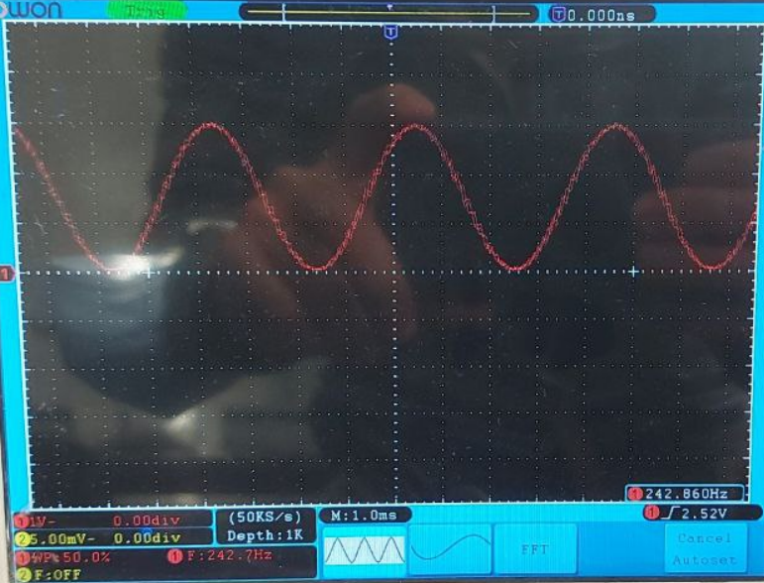

Fig. 19 Full Wave

Fig. 18 Sine

Fig. 20 Half Wave

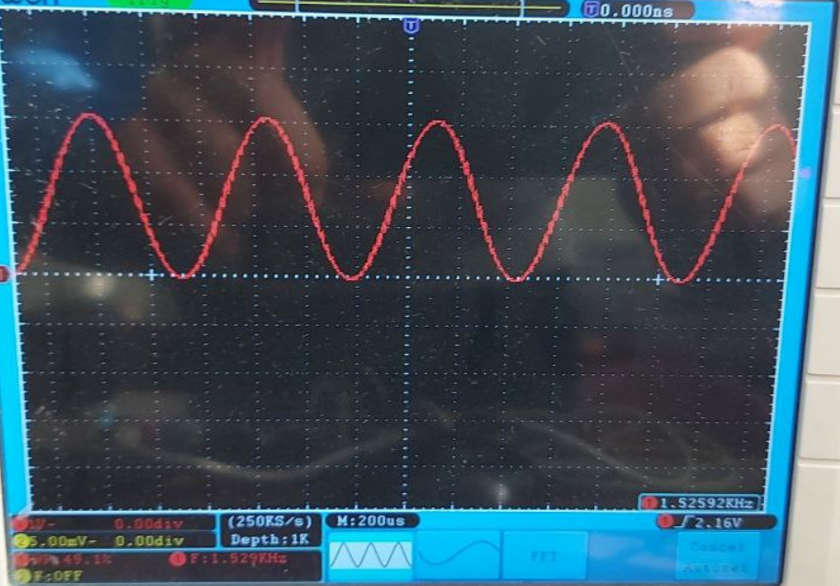

Fig. 21 DDS phase = 0

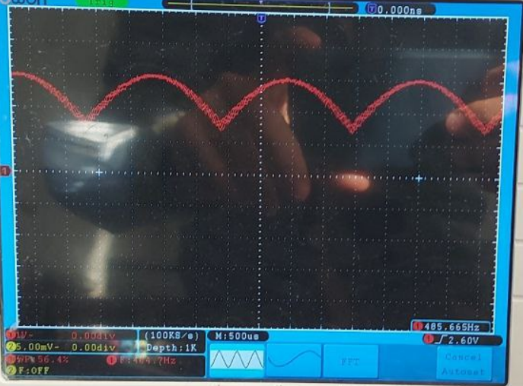

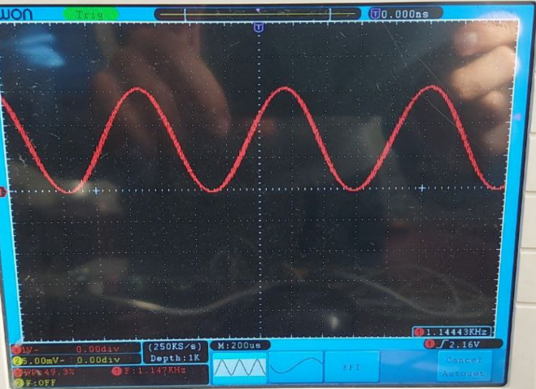

Fig. 22 DDS phase = 1

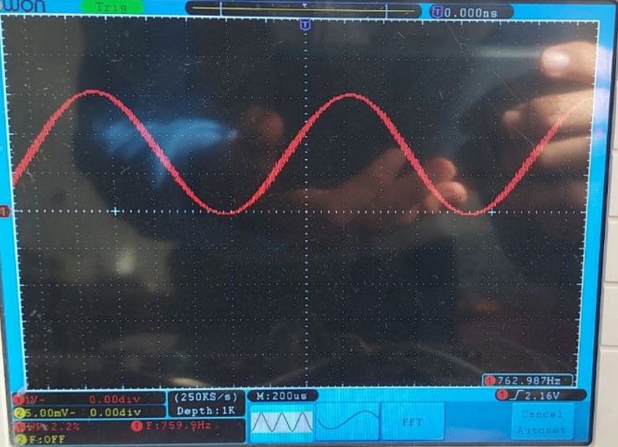

Fig. 23 DDS phase = 2

VII. **Conclusion**

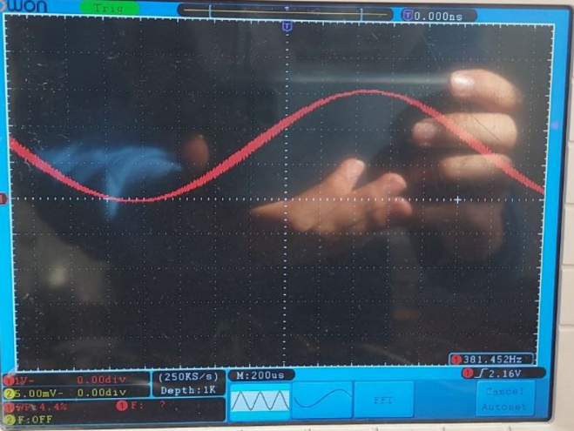 In this experiment, we programmed a **Waveform Generator** with ModelSim and Quartus II and we designed different waves and change their domain and frequency, at last, we created a PWM to convert digital to analog.

Fig. 24 DDS phase = 3